Attachment B Scope of Work

PROJECT: Utah San Rafael Energy Lab Perimeter Fence.
LOCATION: 800 North Coal Haul Road, Orangeville, Utah 84537.

- Introduction

This is an outline for the removal of 3,600ft of existing fence, and the installation of a new property perimeter fence, for the property surrounding the Utah San Rafael Energy Lab (USREL). It will need approximately 5120ft of 8ft chain-link with Razor wire (no climb). It needs to be done with the utmost quality to ensure the security of our facility. We need the fence installed in a timely manner because security is a growing concern.

This Scope of Work will be issued under [USREL New Perimeter fence #].

  - Background

The Utah San Rafael Energy Lab management team has decided it is in our best interest to make the fence a priority moving forward. We currently have a fence, but it does not surround the actual property line and its quality of security has diminished over the years. Therefore, we are going to undertake this project to ensure the safety, security and image of the Utah San Rafael Energy Lab.

Site Specifics
Location and Description: Work on this Contract is located in the industrial park just off of Coal Haul Road West of Orangeville Utah. The property that needs a new perimeter fence is the 40 acres surrounding the Utah San Rafael Energy Lab. This will depend on funding and price per footage to build. Construction of new fence and removal of old fence are shown in photo 1:A.

  - Scope of Work

The Utah San Rafael Energy lab is soliciting bids to remove 3,600’ of existing fence and to construct approximately 5,120 feet of chain-link fence, 8 feet in height, topped with razor wire. This bid is to provide labor and materials to construct the identified fencing project as specified. This project is located at the Utah San Rafael Energy Lab property in Orangeville, Utah. The property spans 40 acres that needs to be enclosed with new fencing. See attached photo for projection of area that needs fencing (red is fenceline to be removed, green is where new fence will be installed). The posts will be galvanized steel spaced no more than 10 feet apart. Each corner shall have Diagonal bracing going in both directions. Chain-link will be attached to the outward facing portion of the posts for the full perimeter of the fence. A new 40-foot gate will need to be installed at the main entrance of the facility. Gate shall have to have new “gate operators” installed and the old ones removed. The fence will then need to have (no climb) razor wire attached to the top for the full perimeter of the property. After construction of the new perimeter fence, the old perimeter fence will need to be deconstructed and hauled away from the property. The successful bidder (contractor) will construct the fence as specified and will provide all labor and equipment necessary to complete the fence as specified.

General Fence Specifications
8-foot Chain-link No climb fence.

Posts

- All posts shall be 1 5/8” in diameter and stand 8 feet above the surface.
- All galvanized steel posts shall be set plumb (vertical) in complete straight line set 2.6 feet under ground and encased in concrete.
- All posts shall be spaced 10 ft. apart for the full perimeter of the property excluding where new gate will be constructed.

Fencing
- Chain link fencing shall consist of a diamond opening of 1-1/4” and be 96” in height.
- Chain link must be fastened to posts in such a way that it cannot be easily tampered with to ensure maximum security.
Braces
- Each corner will have corner bracing spanning from top corner of corner post to bottom of next post in both directions going outward from corner.
Razor Wire.
- The new perimeter fence will be topped with razor wire spanning the entire perimeter of the property to ensure maximum security in the facility.
- Razor wire will have 24” coils and be tied every 12” to the top cross brace of the fence.
Gates
- A new 40-foot-wide gate will need to be installed in the same location as the current fence.
- New gate operators will need to be installed to control the new gate.
- Utility power is already at the location of the gate, but any further tampering will have to be done by the contractor, or by a licensed electrician.
- The new gate will also be constructed of galvanized posts, chain-link on the outward facing side of the gate, and topped with razor wire.
- The gate will need to be automated and compliant with the current software that the Utah San Rafael Energy Lab used to automate their gate.

Additional Fence Specifications, details, requirements and Information.

The fence is being constructed on State property and should be respected and taken care of. No garbage or extra of any kind should be left behind after construction is completed. The contractor shall be responsible for clearing and leveling the land that has not been previously worked.

Fence Materials
Bidders must submit “Cut Sheets” or Manufacturer Specifications with their bid to prove compliance. The Selected bidder will provide all fence material necessary to construct the fence as specified:
- Galvanized steel fence posts 10.5 feet in length with a 1-5/8” diameter.
- Chain-Link with a diamond opening of no more than 1-1/4”.
- Galvanized Corner bracing posts.
- Razor wire (maximum security) to top new perimeter fence.

Clearing of fence line
- The fence line is on mostly flat, workable ground. However, the contractor will be responsible for clearing, leveling, etc. any ground that needs it to successfully install the fence.

Site Investigation and Conditions Affecting the Work.
The Contractor acknowledges that it has take steps reasonably necessary to ascertain the nature and location of the work, and that it has investigated and satisfied itself to the general and local conditions which can affect the work or its costs, including but not limited to:
- Conditions bearing upon transportation, disposal, handling and storage of materials;
- Availability of labor, electric power, and roads;
- Uncertainties of weather, or similar physical conditions on the site;
- Conformation and conditions of the ground; and
- Character of equipment and facilities needed preliminary to and during work performance.

Any failure of the Contractor to take the actions described and acknowledged in this paragraph will not relieve the Contractor from responsibility for estimating properly the difficulty and cost of successfully performing the work, or to proceed to successfully perform the work without additional expense to the State.

Only areas shown on the Project Map will be constructed. The project areas are identified with GPS unit. It will be the contractor’s responsibility to provide a GPS that can load project location areas from a
computer if requested.

Government staff will identify unit boundaries for the work carried out under the contract. The Contractor shall immediately upon entering the project area, begin work, locate control points, section corners, and take such action to prevent their destruction.

Security of Equipment and Property;

- The contractor may leave equipment at the work site, however, the Contractor shall be solely responsible for protection of equipment and is solely responsible if the equipment is lost, stolen or damaged.
- The contractor shall not tamper with the existing fence until the new fence is to a standard that will ensure the utmost security of the facility.

Crew Supervision

- Contractor shall designate one English literate supervisor who will be on-site during construction hours. Supervisors shall be identified to contract owner, and any change in supervisory designations must be reported verbally or digitally to the contract owner in a timely fashion.
- Person designated by the Contractor, as supervisor must remain with and effectively direct the crew by (1)making periodic inspections of the crews work (2) advising them as to improper work methods, (3) providing instructions for correcting any improper work methods encountered.
- Emergency transportation will be provided by the Contractor at all times.

Work Hours

Work hours under this contract shall be determined by the Contractor. Work can be done on this project at any time in order to meet the deadline of the project. Work hours may extend into darkness only when the contractors equipment is suitably outfitted with exterior lighting sufficient to allow safe operation.

- Compliance

This project will be contracted to a third-party company. However, USRELI will be overseeing the progress and working with this third party to make sure we are on schedule and budget. USREL will also oversee the quality of the job being done to make sure it is going to suit us to our expectations.

Inspection
Surveillance Plan: The Contractor is responsible for providing quality control to assure that work complies with the contract specifications.

SITE VISIT:
A mandatory site visit will be held on February 10, 2026, at 10:00 am. We will meet at the Utah San Rafael Energy Lab located 800 North Coal Haul Road Orangeville, Utah. A sign-in sheet will be provided for all attendees to sign in with company name, contact person, phone number and email. Please be prepared to travel off road through rough terrain, on paved and gravel roads where you may need a high clearance vehicle or four wheel drive to view the project sites. Per Utah Procurement Rule R33-101-13 Pre-Bid Conferences and Site Visits. Mandatory site visits must be attended in person by an authorized representative of the person or vendor submitting a bid. The meeting will begin promptly at the specified time. Any prospective bidders who arrive late to the meeting will not be allowed to continue with the site visit nor submit a bid. Failure to attend the site visit shall result in the disqualification of any bidder who does not have an authorized representative attend the entire duration of the mandatory site visit. This includes not taking calls/texts during the site visit. Phones may be used to take pictures. All discussions not related to the site visit must be done after the site visit to avoid disturbing attendees. An attendance log will be maintained including the name of each attendee, the entity the attendee represents, and the attendee’s contact information, minutes of the site visit, and copies of any documents distributed by the conducting procurement unit to the attendees and shall be published as an addendum to the solicitation. Any verbal modifications made to any of the solicitation documents during the mandatory site visit shall be reduced to writing and will be published as an addendum to the solicitation.

Questions
Only questions specific to the site should be asked at the site.

- Project Deliverables

In coordination with the contractor constructing the fence (USREL) will oversee the progress being made each day to see if we are on schedule and on budget. I will relay this information to my supervisor and he to his supervisor. No staff at USREL will at any time be responsible for any work done on the fence once the contractors have started construction.

Bidding

This contract will be bid on a linear foot basis. The total price shall include all labor, fencing materials, equipment and materials necessary to complete the job, which includes all mobilization and operating costs. There will be no fuel surcharges or adjustments negotiated.

- Project Timeline

Period of Performance Window; February 15th, 2026-May 26th, 2026.
- Evaluations and Basis for Award.
Mandatory Minimum Requirements (Pass/Fail)
Proposals will first be screened for responsiveness. Bidders must meet the following mandatory qualification to move forward to the technical and price evaluation phase. Failure to meet this requirement will result in the bid being deemed "Non-Responsive."
- Experience & Qualifications: The Bidder shall provide evidence of having successfully completed at least three (3) security fencing projects of similar scale and complexity within the last five (5) years. Bidders must provide a reference name and contact information for each project.
- Site visit: The bidder must attend the mandatory site visit as outlined in the site visit section.

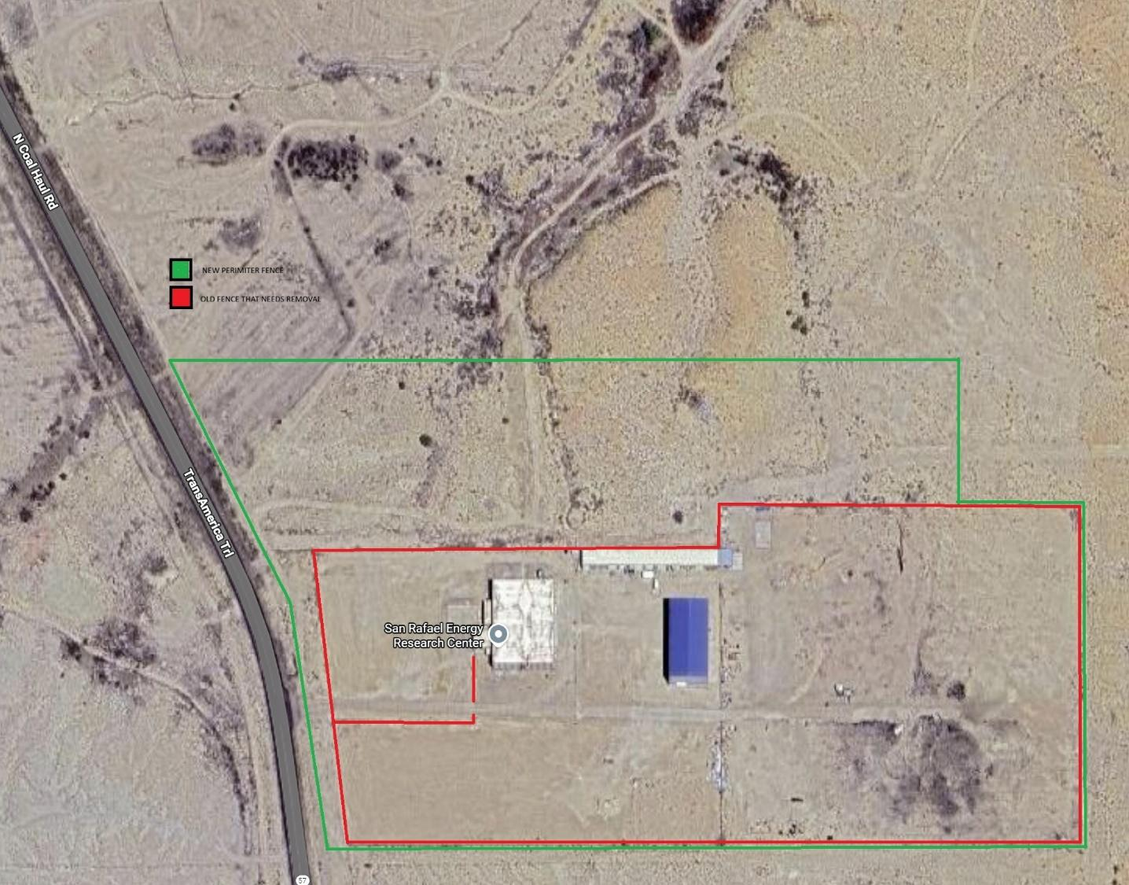

1:A Map of projected fence line.

